**Unintended consequences of climate-adaptive fisheries management targets**

Cody S. Szuwalski1, Anne B. Hollowed1, Kirstin K. Holsman1, James N. Ianelli1, Christopher M. Legault2, Scott McCorquodale3, Michael C. Melnychuk4, Dan Ovando4, Andre E. Punt4

1 Alaska Fisheries Science Center, NOAA, Seattle, WA

2 Northeast Fisheries Science Center, NOAA, Woods Hole, MA

3 Washington Department of Fish and Wildlife, Olympia, WA

4 University of Washington, Seattle, WA

Climate change is projected to affect the productivity of global fisheries. Management based on Maximum Sustainable Yield (MSY) has been effective at eliminating overfishing in many regions. However, continuing to use yield-maximizing targets under climate-driven changes in productivity can result in higher anthropogenic pressure on populations subject to climate-related stress than maintaining *status quo* management targets. We demonstrate this effect using a theoretical example and case studies from snow crab in the Bering Sea and a global marine fisheries database. In these examples, the conservation gain (i.e. biomass in the ocean) of maintaining *status quo* management targets is larger than the small gain in harvest made through climate adaptation in MSY-based management. The aggregate conservation gain of maintaining management targets increases as harmful impacts of climate change on productivity worsen. Instead of climate-adaptive targets, new management tools are needed to balance conservation and food production in ecosystems of populations displaying non-stationary productivity.

Harvested living marine resources support ecosystem function, economic development, and food/nutritional security on a global scale. Wild inland and marine capture fisheries produced 96.4 million tons of seafood and fisheries trade had an export value of $164 billion worldwide in 2018 (1). Globally, food from the sea constitutes 17% of the animal protein consumed, but can exceed 50% in some areas (1). Marine resources must be sustainably managed so that society can continue to benefit from the ecosystem services they produce. Sustainable harvests of fished species are determined by the productivity of the resource, which is determined by ecological and biological processes such as somatic growth, natural mortality, reproduction, competition, and resource limitation.

Climate change is already influencing the productivity of harvested marine populations. Warming temperatures are influencing somatic growth rates and reproductive capacity of fishes (2,3). Spatial distributions of species are changing, which may have consequential effects on processes ranging from nutrient cycling to predation and competition (4). Diseases and infestations will vary as environmental conditions change and stressors mount (5). The increasing intensity of marine heat waves will affect the availability of suitable habitat, and may induce reinforcing cycles of decline, further impacting productivity (6,7). Ocean acidification is altering various aspects of the physiology of marine organisms (8). These stressors will act in concert to influence the productivity of many harvested populations, and by extension potential sustainable harvest rates

Harvested natural resources are often managed using targets for population sizes and harvest rates based on the concept of maximum sustainable yield (MSY; 9). MSY management targets reflect the productivity of a population, and highly productive populations can be harvested more intensely than populations with lower productivity. MSY-based management is largely responsible for the improvement of the status of fisheries globally over the past few decades. The median assessed fishery in 1995 was fishing at a level ~25% higher than the exploitation rates that would produce MSY (UMSY); in 2010, the median exploitation rate was ~25% less than UMSY (10). Many MSY-based management frameworks specify that targets should reflect the productivity determined by current environmental conditions. For example, the U.S.A. Magnuson Stevens Act specifies that ‘optimum yield’ shall be achieved by specifying ‘the present and probable future condition of, and the maximum sustainable yield’ from a fishery in the U.S.A (11). Consequently, determining the period of time to serve as a reference for productivity is a part of the decision making process in U.S. fisheries management.

Climate-change induced shifts in productivity may imply that the frames of reference for MSY-based management targets will need to change. Here, we demonstrate counter-intuitive changes in harvest rates resulting from the application of climate-adaptive management targets (i.e. those that ‘adapt’ to new productivity by using only recent data in management targets) compared to holding targets constant at a *status quo* level. We show this pattern to be consistent using a simulated population, a fished population of snow crab (*Chionoecetes opilio*) in the eastern Bering Sea, and a database of output from global fisheries assessments. We conclude with a discussion of the potential solutions to the unintended consequences of climate-adaptive management.

Harvested populations can be modeled with logistic population models that depend on an intrinsic growth rate, *r*, and a resource carrying capacity, *K* (9). Under the logistic model, populations are most productive and thus can sustain the greatest annual harvest at intermediate levels of biomass. The value of biomass and harvest rate that produce maximum sustainable yield (BMSY and UMSY, respectively) can be derived from these models and incorporated into harvest control rules to calculate allowable harvests (Figure 1). The ‘sloped’ harvest control rule is one of the most powerful conservation tools at the disposal of managers (10). It dictates that harvest rates, and hence human impacts, decline from a target harvest rate as the biomass of a resource declines below a threshold. The decline in harvest rate serves both to accelerate rebuilding of the population to levels thought to maximize long-term yield and to protect the population from declining to low levels.

To demonstrate the impacts of changing management targets, we simulated a harvested resource with a logistic population model for 100 years in which the carrying capacity was halved at year 50 (from KA to KB in Figure 1) but the intrinsic rate of growth remains unchanged, reducing the MSY of the resource. The initial trajectory of simulated harvest rates progressed from low levels to rates beyond the management target, and finally declined, returning to near the management target (Figure 1). When a productivity change occurs (the halving of K in year 50), the manager of this population is faced with a decision: should the management targets be maintained at *status quo* levels (point A) or changed to reflect the decrease in productivity (point B)?

We can look at the estimated position of the population relative to the management targets to understand the decision the manager faces. Within the frame of reference of the *status quo* management targets, the year-50 biomass is less than the target biomass set based on KA. Consequently, the harvest control rule dictates that harvest rates should decrease to allow the resource to rebound (Figure 1). However, if ‘climate-adaptive’ management targets are used, the year-50 biomass is above the new target biomass based on the lower KB. This indicates harvest rates should be maintained to reduce the population to the new biomass target. If the productivity of a resource decreases and management adjusts to the new productivity regime, harvest rates can increase or be maintained compared to a *status quo* control rule. Conversely, if productivity increases and management adjusts, harvest rates can be lower than those under a *status quo* rule. These responses are opposite to what one might expect from managers when managing populations experiencing stress or flourishing under new environmental conditions.

The logistic population model oversimplifies reality and is rarely used in management because of its shortcomings. We developed a more realistic population model to explore the impact of climate-adaptive management targets for snow crab in the eastern Bering Sea.

Snow crab have been commercially fished in the eastern Bering Sea since the mid-1970s and the fishery only harvests large males. Snow crab reproductive dynamics appear to be influenced by environmental conditions, particularly sea ice, and through mechanisms quantified by the Arctic Oscillation (12). Projections of environmental indices from global climate models coupled with models of historical recruitment (i.e. young crab entering the population) suggest that the recruitment of snow crab will decrease as sea ice disappears from the eastern Bering Sea and the cold pool shrinks (Figure 2). These changes in predicted recruitment affect forecasts for biomass, and in turn, for sustainable yield (see SI for details).

For snow crab, climate-adaptive management targets dictate higher harvest rates than *status quo* rules in response to a decrease in productivity (Figure 2). Yields increase initially as harvest rates are maintained at high levels under the climate-adaptive targets, but eventually decline below the yields achieved under the *status quo* harvest control rule. Projected average catch from 2030 to 2040 was 19% higher under climate-adaptive management targets, but starting in 2050, maintaining *status quo* management targets provided 10% higher yields and left XX% more biomass in the ocean.

The influence of a changing climate on snow crab outlined here operated through reproductive dynamics, but other population processes could be affected, like natural mortality or growth. Changes in recruitment primarily influence the target biomass (13), but a change in growth or natural mortality would change the both target harvest rate and target biomass (14). An increase in natural mortality or a decrease in growth (i.e. declines in productivity) resulted in higher target harvest rates and lower target biomasses under a climate-adaptive management for snow crab, increasing the potential harm from adaptation (Figure S3 and S4).

The problems presented by changing productivity are not simply a theoretical idea that managers may have to grapple with in the future. Decisions to maintain or change reference points under changes in productivity are already occurring. For example, Tanner crab (*Chionoecetes bairdi*) in the eastern Bering Sea had management targets redefined in 2013 that allowed higher harvest rates than would have been implemented under the *status quo* (15). Jackass morwong (*Nemadactylus macropterus*) in southeastern Australia underwent a revision of management targets in 2018 after an apparent shift in recruitment, which resulted in higher harvest rates on a stock with a lower maximum production (leading to heated debates; 16, 17). The heavily depleted Jack mackerel (*Trachurus murphyi*) stock has recently come under international management by the South Pacific Regional Fisheries Management Organization (SPRFMO). Instead of ‘adapting’ to what appears to be a new regime of lower than average recruitment, managers selected target reference points to improve the chance of stock rebuilding.

In addition to the specific management decisions above, analyses exist in the literature that evaluate management strategies under both gradual and regime-like shifts in productivity. A’mar et al. (18) developed full-feedback analyses that simulated every aspect of the management system for walleye pollock (*Gadus chalcogrammus*) in the Gulf of Alaska (i.e. scientific surveys, stock assessment, fishery dynamics, population dynamics, and management decisions) to evaluate control rules given shifts in productivity. They found that climate-adaptive management targets failed to markedly improve management performance. Other published management strategy evaluations produced similar outcomes (19, 20), but were based on single species evaluations. Changing productivity will likely affect interacting species in unique ways (21), so examining aggregate outcomes for managed populations with different responses to climate changes may provide insight for management.

The RAM Legacy Stock Assessment Database (RAMLDB) is a collection of estimates of the harvest history, biomass, and status for over 590 harvested marine populations that account for roughly one half of global marine fisheries production through the year 2010 (22). We fit logistic models to the fishery data individually for each population to parameterize models to be projected forward, and then performed 100 simulations in which the populations were projected for 50 years. Carrying capacity for each population was multiplied by a normal random variable with mean 0.5 or 1.5 and a standard deviation of 0.1 in the year 2040. Finally, we compared the trajectories of biomass and yield achieved by applying HCRs with climate-adaptive or *status quo* management targets over the projection (see SI for details).

Projected total biomass was 8% higher under *status quo* targets than climate-adaptive targets, yet total projected yield increased by only 3% under adaptation (Figure 4). The relatively small changes in yield but larger changes in biomass can be understood by comparing the results for declining stocks with increasing populations. The biomass for increasing populations equilibrated at the same levels over time and produced similar yields under both harvest control rules. The most notable difference in contribution to total biomass and yield arose from the declining populations. The climate-adaptive management targets depleted these populations to levels 34% lower than those under the *status quo* targets, but only increased yield by 10%.

The above results were generated for scenarios in which the increases in MSY were balanced by the decreases in MSY. However, if more populations were negatively influenced by climate change than were positively influenced, the conservation benefits of maintaining *status quo* targets would become larger as the projected biomass sums between approaches diverge (Figure 5). Aggregate yield trended downward with more populations negatively influenced by climate change for both strategies, but the difference between the strategies for a given proportion was small. Changing productivity can also influence target harvest rates (Figure S3), so the impact on vulnerable populations of using climate-adaptive management targets is likely larger than reported here.

Climate-adaptive management resulted in slightly higher aggregate yields for our global fisheries case study, but the small gains were overshadowed by losses in biomass disproportionately incurred by populations under stress. This result could be considered expected —the key goal of MSY is to maximize yield. It may also not have be surprising that lower exploitation rates under *status quo* management can provide similar yields (see Hilborn’s ‘pretty good yield’; 23). However, for many managers and stakeholders, MSY-based management has become synonymous with ‘good’ management. Conservation benefits were a desired but not fundamental side effect of attempting to maximize yields in populations that had a history of over-exploitation, and MSY-based management has eliminated overfishing in many regions. However, it may be necessary to reconsider the use of yield-maximizing strategies to accommodate both conservation goals and food production under widespread changes in productivity.

Maintaining *status quo* management targets may be an acceptable default management approach under changing productivity because it preserves the conservation intent of management (i.e. to lessen anthropogenic impacts on populations under stress) while still providing aggregate yields that are not markedly lower than can be achieved by changing management targets. Maintaining *status quo* targets also builds in precaution by acknowledging that populations have evolved survival strategies that may be fundamentally altered under climate change, with insufficient time to adapt alternatives. However, choosing this path can sever the link between the current productivity of the population and management targets. A portion of this decision hinges on a manager’s expectation of the likelihood of mitigating climate change impacts. If climate change impacts are successfully mitigated, acknowledging a change in productivity as an additional source of anthropogenic mortality and managing under the expectation that the additional mortality may eventually be removed may be appropriate.

Although maintaining *status quo* management targets may be an acceptable default, other factors may influence the decision to change or maintain targets. Economic incentives exist for maintaining yield from high value resources. Higher levels of biomass in ecosystems may decrease the costs to fishers of finding and capturing fish. Ecosystem interactions also provide management incentives: for example, if a prey species experiences a drop in productivity, but supports an array of harvested predator species, maintaining higher biomass management targets for the prey species may be warranted (24). Methods of harvesting resources can interact (e.g. fishing in one area with one gear may result in harvest of many species). If co-harvested species respond differently to shifting climate, species with declining productivity may impede the utilization of co-harvested species with increasing productivity (25).

Societies value ecosystem services differently and might, for example, place larger emphasis on food production compared to ecosystem structure (26). The winners and losers of climate change will not be randomly scattered around the globe—there will likely be hotspots of productivity loss and gain, and the difference between local and global outcomes may strongly affect management decisions, particularly in developing countries (27). The uncertainty and risk surrounding projected resource response and market conditions will further complicate managing resources under climate change. For example, aquaculture provides an increasingly large fraction of global seafood and may be able to supplant wild-capture seafood over time (as has been seen in China, 28). Increased seafood supply via aquaculture may offer further support for managing declining wild resources conservatively and maintaining *status quo* targets.

There will likely be no one-size-fits-all solution for managing fisheries under a changing climate and, although *status quo* management may be a useful default, this does not mean improvements cannot be made (30). Large scale efforts are underway attempting to predict the impact of climate change on natural resources (e.g. 31, 32, 33). Our results do not negate the importance of these studies and we stress the need to consider economic, ecological, and social consequences in management decisions. Furthermore, our analyses concerned already-managed fisheries—fisheries that produce nearly half of the world’s catch are still minimally managed and would benefit from basic fisheries management (e.g. 34). Nonetheless, we have outlined a counter-intuitive consequence of applying existing MSY-based management principles to resources undergoing changes in productivity. In isolation, repercussions of single instances of climate-adaptive MSY-based management may not have large ecological or economic impacts. However, multiple interacting resources responding to a rapidly changing climate could result in destabilization of both ecosystems and markets. The net effect of seemingly small, well-intentioned decisions by managers around the globe may translate to large changes in both the biomass of harvested populations remaining in the ocean and harvest levels. Concerted international planning among managers is needed to confront the potential problems introduced by climate-induced changes in productivity. This planning will require explicitly identifying tradeoffs and agreeing upon preferences, which will necessitate honest discussions about the goals of management, data sharing, and collaborative analysis.In particular, managers may be faced with a choice of pursuing biomass levels consistent with a pre-warming past, or yields reflective of a post-warming future.

There are myriad ways to model changes in productivity and management response to them. Our goal with this paper was not to exhaustively explore this space, but rather to emphasize that managers will increasingly face decisions about how to manage changing resources and note that ‘climate-adaptive’ management is often presented as the gold standard to improve management outcomes (35). We reinforce previous literature which showed that following the MSY paradigm may produce undesirable conservation outcomes for single populations and add that, when considered in aggregate, populations under climate stress would receive the brunt of the harm from MSY-based adaptation. Larkin published “An epitaph for maximum sustainable yield” in 1977 decrying the shortcomings of MSY (36). In spite of the problems he identified, MSY-based management has played a critical role in rebuilding global fisheries (10). The successes of MSY-based management should be celebrated, but the looming problem of changing productivity requires renewed scrutiny by the scientific community to safeguard marine resources for future generations.

*Acknowledgements*

We thank Brock Hoenes and Kyle Garrison for helpful comments on an earlier draft. We also thank THESE REVIEWERS.

*Reproducibility statement*

All code and data used to perform this analysis can be found at:

https://github.com/szuwalski/INSERT_NEW_REPO

*References*

1. FAO. (2020) The State of World Fisheries and Aquaculture 2020. (https://www.fao.org/publications/sofia/2020/en/)
2. Huang, M.Ding. L., Wang, J., Ding, C., Tao, J. (2021) The impact of climate change on fish growth: A summary of conducted studies and current knowledge. Ecological Indicators. 121: 106976.
3. Britten, G. et al. 2016. Changing recruitment capacity in global fish stocks. Proceedings of the National Academy of Science. 113(1): 134-139.
4. Pinsky, M.L., Worm, B., Fogarty, MJ., Sarmiento, J.L., Levin. S.A. (2013) Marine taxa track local climate velocities. Science 341: 1239-1242.
5. Tracy, A.M., Pielmeier, M.L., Yoshioka, R.M., Heron, S.F., Harvell, C.D. (2019) Increases and decreases in marine disease reports in an era of global change. Proceedings of the Royal Society B. 286: 20191718.
6. Frolicher, T.L., Fischer, E.M., Gruber, N. (2018) Marine heatwaves under global warming. Nature. 560: 360-364.
7. Holbrook, N.J., Scannell, H.A., Sen Gupta, A. *et al.* (2019) A global assessment of marine heatwaves and their drivers. Nature Communications. **10,** 2624-2630.
8. Fabry, V.J., Seibel, B.A., Feely, R.A., Orr, J.C. (2008) Impacts of ocean acidification on marine fauna and ecosystem processes. ICES Journal of Marine Science 65(3): 414-432.
9. Schaefer, M. B. (1957) A study of the dynamics of the fishery for yellowfin tuna in the eastern tropical Pacific Ocean. *Inter-American Tropical Tuna Commission Bulletin*, 2: 245–285.
10. Hilborn, R. et al. (2020) Effective fisheries management instrumental in improving fish stock status. Proceedings of the National Academy of Science. 117(4): 2218-2224.
11. Magnuson-Stevens Fishery Conservation and Management Reauthorization Act of 2006. (2007) Pub. L. No. 109-479, 120 Stat. 3575.
12. Szuwalski et al. (2020) Climate change and the future productivity and distribution of crab stocks in the Bering Sea. ICES Journal of Marine Science.
13. Szuwalski, C.S. and Punt, A.E. (2013) Fisheries management for regime-based ecosystems: a management strategy evaluation for the snow crab fishery in the eastern Bering Sea. ICES Journal of Marine Science. 70(5): 955-967.
14. Legault, C.M. Palmer, M.C. (2016) In what direction should the fishing mortality target change when natural mortality increase within an assessment? Canadian Journal of Fisheries and Aquatic Science. 73(3): 349-358.
15. Stockhausen, W. T. (2019) 2019 stock assessment and fishery evaluation report for the Tanner crab fisheries of the Bering Sea and Aleutian Islands regions. In Stock Assessment and Fishery Evaluation Report for the King and Tanner Carb Fisheries of the Bering Sea and Aleutian Islands Regions, pp. 293–440. North Pacific Fishery Management Council. Anchorage, AK.
16. Edgar, G.J. Ward, T.J., Stuart-Smith, R.D. (2018) Rapid declines across Australian fishery stocks indicate global sustainability targets will not be achieved without an expanded network of ‘no-fishing’ reserves. Aquatic Conservation: Marine and Freshwater Ecosystems. 1-2.
17. Little, L.R. et al. (2019) Comment on the evidence for the recent claim on the stat of Australian fish stocks. Aquatic Conservation: Marine and Freshwater Ecosystems. 28: 1337-1350.
18. South Pacific Regional Fisheries Management Organization, SPRFMO (2013). 1st Scientific Committee meeting report. 101p. Wellington, New Zealand 2013.
19. A’mar, Z.T., Punt, A.E., Dorn, M.W. (2009) The impact of regime shifts on the performance of management strategies for the Gulf of Alaska walleye pollock (*Theragra chalcoggramma*) fishery. Canadian Journal of Fisheries and Aquatic Science. 66: 2222-2242.
20. Punt, A.E., A’mar, T., Bond, N.A., Butterworth, D.S., de Moor, C.L., de Oliveira, J.A.A., Haltuch, M.A., Hollowed, A.B., Szuwalski, C.S. (2014) Fisheries management under climate and environmental uncertainty: control rules and performance simulation. ICES Journal of Marine Science. 71(8): 2208-2220.
21. Klaer, N.L. et al. (2015). How much evidence is required for acceptance of productivity regime shifts in fish stock assessments: Are we letting managers off the hook? Fisheries Research. 168: 49-55.
22. Szuwalski, C.S., Hollowed, A.B. (2016) Climate change and non-stationarity population processes in fisheries management. ICES Journal of Marine Science 73(5): 1297-1305.
23. RAM Legacy Stock Assessment Database. (2020). Extended RAM Legacy Stock Assessment Database version 4.491 (Version v4.491) [Data set]. Zenodo. <http://doi.org/10.5281/zenodo.3877545>
24. Hilborn, R. (2010) Pretty good yield and exploited fishes. Marine Policy. 34: 193-196.
25. Pikitch, E.K. et al., (2014) The global contribution of forage fish to marine fisheries and ecosystems. Fish and Fisheries. 15: 43-64.
26. Burgess, M.G., Polasky, S., Tilman, D. (2013) Predicting overfishing and extinction threats in multispecies fisheries. Proceedings of the National Academy of Science. 110(40): 15943-15948.
27. Szuwalski, C.S., Burgess, M.G., Costello, C., Gaines, S.D. 2017. High fishery catches through trophic cascades in China. Proceedings of the National Academy of Science. 114: 717-721.
28. Oremus, K.L., et al. (2020) Governance challenges for tropical nations losing fish species due to climate change. Nature Sustainability. 3: 277-280.
29. Szuwalski, C.S., Jin, X., Shan, X., Clavelle, T. (2020) Marine seafood production via intense exploitation and cultivation in China; cost, benefits, and risks. PloS one. 15(1): e0227106.
30. Holsman, K.K., Hazen, E.L., Haynie, A., Gourguet, S., Hollowed, A.B., Bograd, S.J., Samhouri, J.F., Aydin, K. Towards climate resiliency in fisheries management. ICES Journal of marine Science. 76(5): 1368-1378.
31. Hollowed et al. (2020) Integrated modeling to evaluate climate change impacts on coupled social-ecological system in Alaska. Frontiers in Marine Science. 6: 775.
32. Peck, M.A. et al. (2020) Climate change and European fisheries and Aquaculture. CERES Project Synthesis Report.
33. Holsman, K.K., Haynie, A.C., Hollowed, A.B., Reum, J.C.P., Aydin, K., Hermann, A.J., Cheng, W., Faig, A., Ianelli, J.N., Kearney, K.A., Punt, A.E. (2020) Ecosystem-based fisheries management forestalls climate-driven collapse. Nature Communications. 11(1): 1-10.
34. Melnychuk, M.C., Kurota, H., Mace, P.M. et al. (2021) Identifying management actions that promote sustainable fisheries. Nature Sustainability. 4(5): 440-449.
35. Bahri, T., Vasconcellos, M., Welch, D.J., Johnson, J., Perry, R.I., Ma, X., Sharma, R. (2021) Adaptive management of fisheries in response to climate change. FAO Fisheries and Aquaculture Technical Paper No. 667.
36. Larkin, P.A., An epitaph for the concept of maximum sustained yield. Transactions of the American Fisheries Society. 106(1): 1-11.

Additional references

1. Thorson, J.T., Minto, C. Minte_Vera, C., Kleisner, K., Longo, K. (2013) A new role of effort dynamics in the history of harvest populations and data-poor stock assessment. Can J Aquat Fish Sci. 70: 1829-1844.
2. Szuwalski, C.S. (2019) 2019 stock assessment and fishery evaluation report for the snow crab fisheries of the Bering Sea and Aleutian Islands regions. In Stock Assessment and Fishery Evaluation Report for the King and Tanner Crab Fisheries of the Bering Sea and Aleutian Islands Regions, pp. 293–440. North Pacific Fishery Management Council. Anchorage, AK.
3. Ricker, W.E. (1954) Stock and recruitment. Journal of fisheries Research board Canada, 11: 559-623.
4. National Oceanic and Atmospheric Administration (NOAA). (2018) Bering climate data portal. [beringclimate.noaa.gov](http://www.foss.nmfs.noaa.gov). Last accessed: 11/2019.
5. Hermann, A.J., Gibson, G.A., Bond, N.A., Curchitser, E.N., Hedstrom, K., Cheng, W., Wang, M., Cokelet, E.D., Stabeno, P.J., and Aydin, K. (2016) Projected future biophysical states of the Bering Sea. Deep Sea Research Part II: Topical Studies in Oceanography, 134: 30–47.
6. Hermann, A.J., Gibson, G.A., Cheng, W., Ortiz, I., Aydin, K., Wang, M., Hollowed, A.B., and Holsman, K.K. (2019) Projected biophysical conditions of the Bering Sea to 2100 under multiple emission scenarios ICES Journal of Marine Science, 76(6): 1280-1304.
7. Dunne, J. P., J. G. John, A. J. Adcroft, S. M. Griffies, R. W. Hallberg, E. Shevliakova, R. J. Stouffer, W. Cooke, K. A. Dunne, M. J. Harrison, J. P. Krasting, S. L. Malyshev, P. C. D. Milly, P. J. Phillipps, L. T. Sentman, B. L. Samuels, M. J. Spelman, M. Winton, A. T. Wittenberg, and N. Zadeh. (2012) GFDL’s ESM2 global coupled climate-carbon earth system models. Part I: Physical formulation and baseline simulation characteristics. Journal of Climate, 25: 6646–6665.
8. Rayner N.A., Parker D.E., Horton E.B., Folland C.K., Alexander L.V., Rowell D.P., Kent E.C., Kaplan A. (2003) Global analyses of sea surface temperature, sea ice, and night marine air temperature since the late nineteenth century. Journal of Geophysical Research, 108: 4407.
9. Compo, G.P., et al. (2011) The Twentieth Century Reanalysis Project. Q. J. R. Meteorological Society, 137:1–28.
10. Lee, J., Sperber, K.R., Gleckler, P.J., Bonfils, C.J. and Taylor, K.E., (2019) Quantifying the agreement between observed and simulated extratropical modes of interannual variability. Climate Dynamics, 52(7-8): 4057-4089.
11. Clark, W.G. (1993) The effect of recruitment variability on the choice of a target level of spawning biomass per recruit. In: Proceedings of the International Symposium on Management Strategies for Exploited Fish Populations. Alaska Sea Grant College Program, AK-SG-93-02.
12. Pella, J. J. and Tomlinson, P. K. (1969) A generalized stock production model. Inter-American Tropical Tuna Commission Bulletin, 13: 419–496.
13. Melnychuk M. C., Baker N., Hively D., Mistry K., Pons M., Ashbrook C. E., Minto C., Hilborn R. & Ye Y. (2020) Global trends in status and management of assessed stocks: achieving sustainable fisheries through effective management. FAO Fisheries and Aquaculture Technical Paper No. 665. FAO, Rome. <https://doi.org/10.4060/cb1800en>
14. Punt, A.E. and Szuwalski, C.S. (2012) How well can FMSY and BMSY be estimated using empirical measures of surplus production? Fisheries Research. 134: 113-124.
15. Lee, Q., Lee, A., Liu, Z., Szuwalski, C.S. (2020) Life history changes and fisheries assessment performance: a case study for small yellow croaker. ICES Journal of Marine Science. 2: 645-654.
16. Szuwalski, C.S. (2016) Production is a poor metric for identifying regime-like behavior in marine stocks. Proceedings of the National Academy of Science. 110(16): E1436-1436.
17. Szuwalski, C.S. (2020) Comment on “Impacts of historical warming on marine fisheries production” Science. 365: 6454.

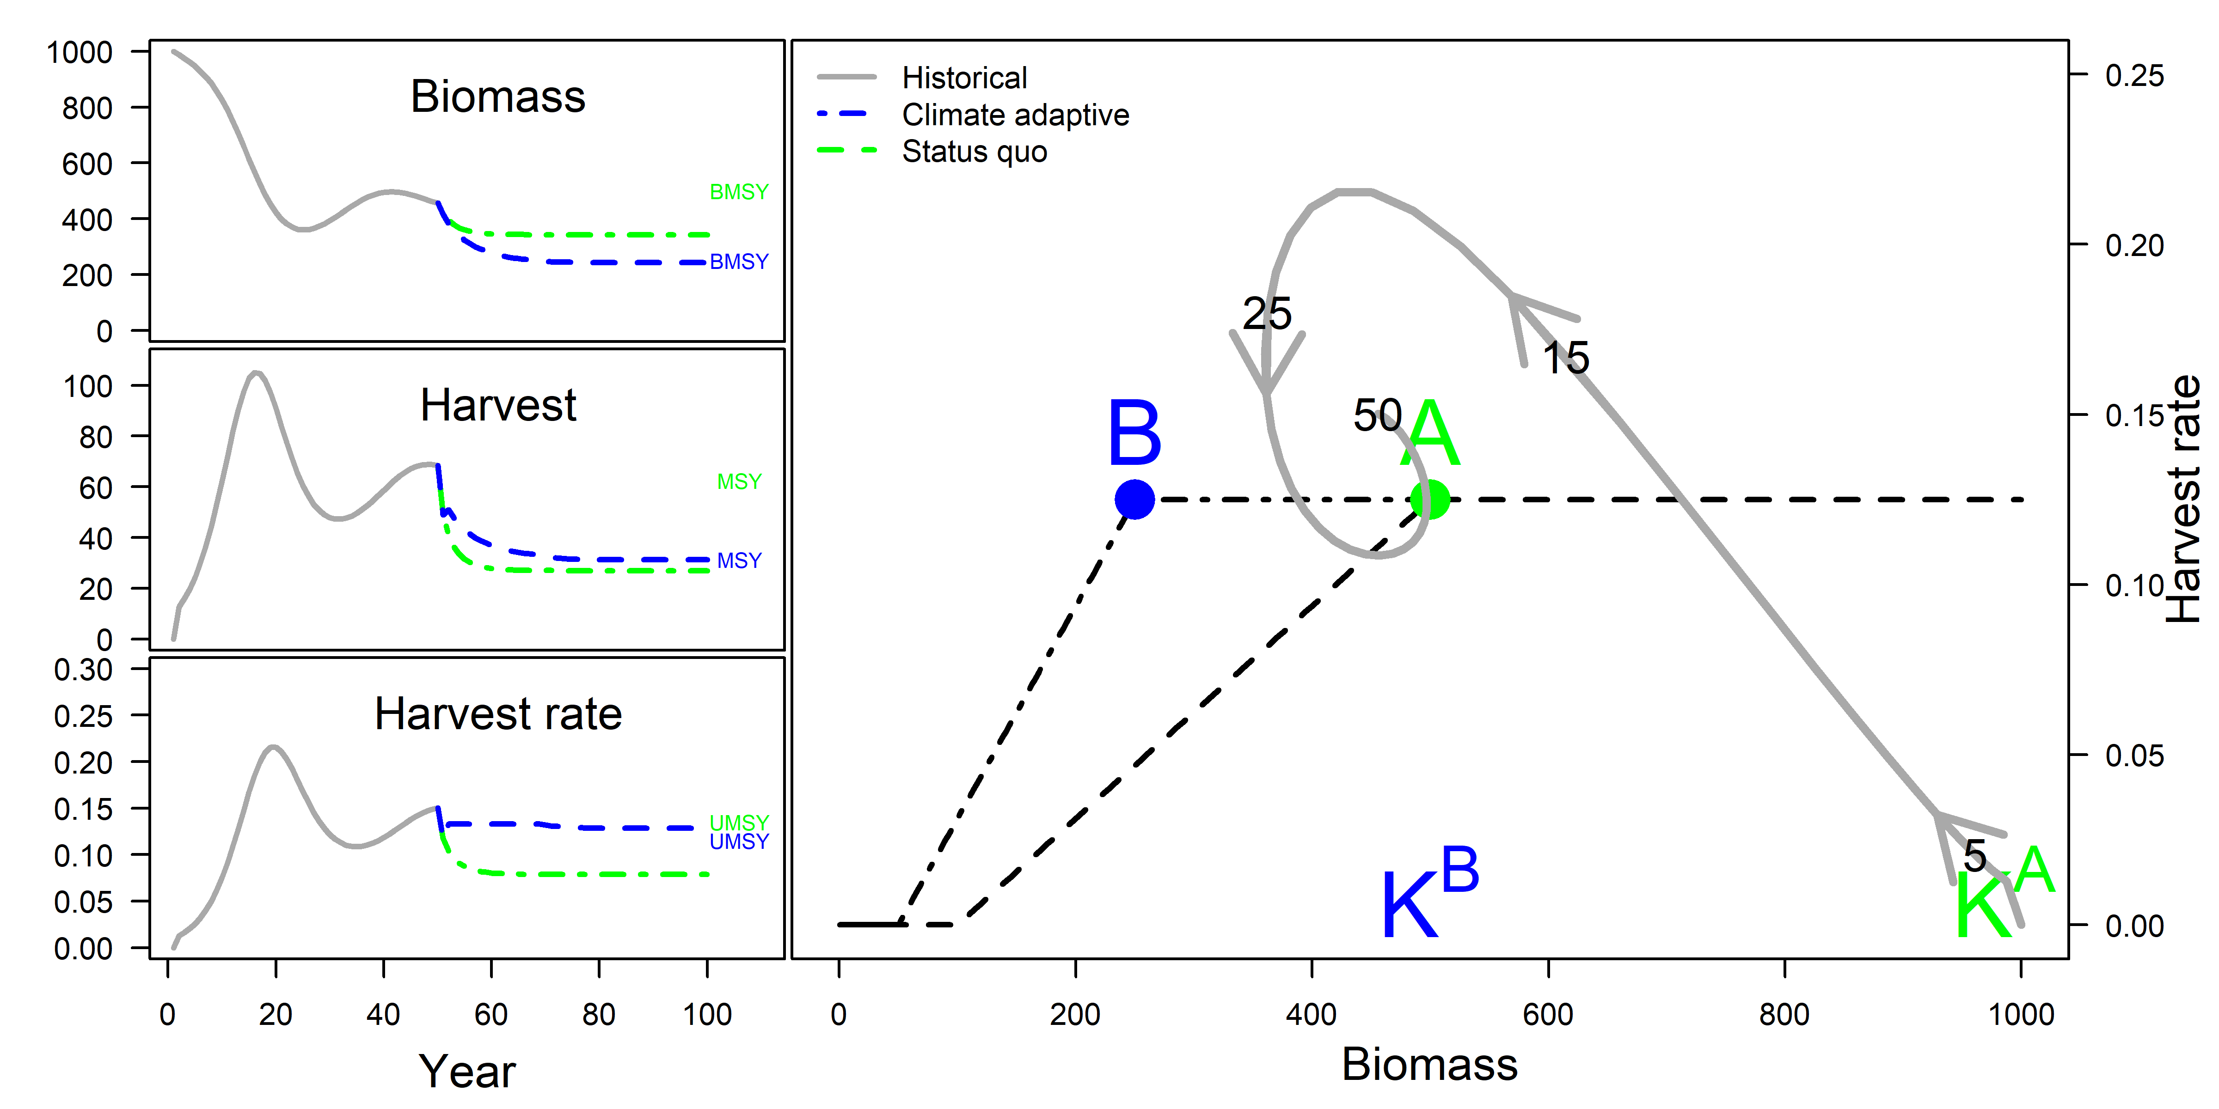

Figure 1. Management challenges in a simulated population undergoing changes in productivity. Trajectories of biomass, harvest, and harvest rates (left panels) under adaptive (blue dash) and *status quo* (green dot-dash) management targets. The value of the management targets (BMSY, MSY, UMSY) for each harvest control rule are noted by the position of the text at the right of each figure. Biomass vs. harvest rate phase space (right panel) maps the population (grey line) through time relative to management targets (numbers correspond to simulation year); during these first 50 years the biomass target was A. In year 50, BMSY changes to B, reflecting an instantaneous decrease in carrying capacity from KA to KB. The harvest control rules resulting from either maintaining *status quo* management targets or adapting to climate change specify the harvest rate to be applied at a given biomass.

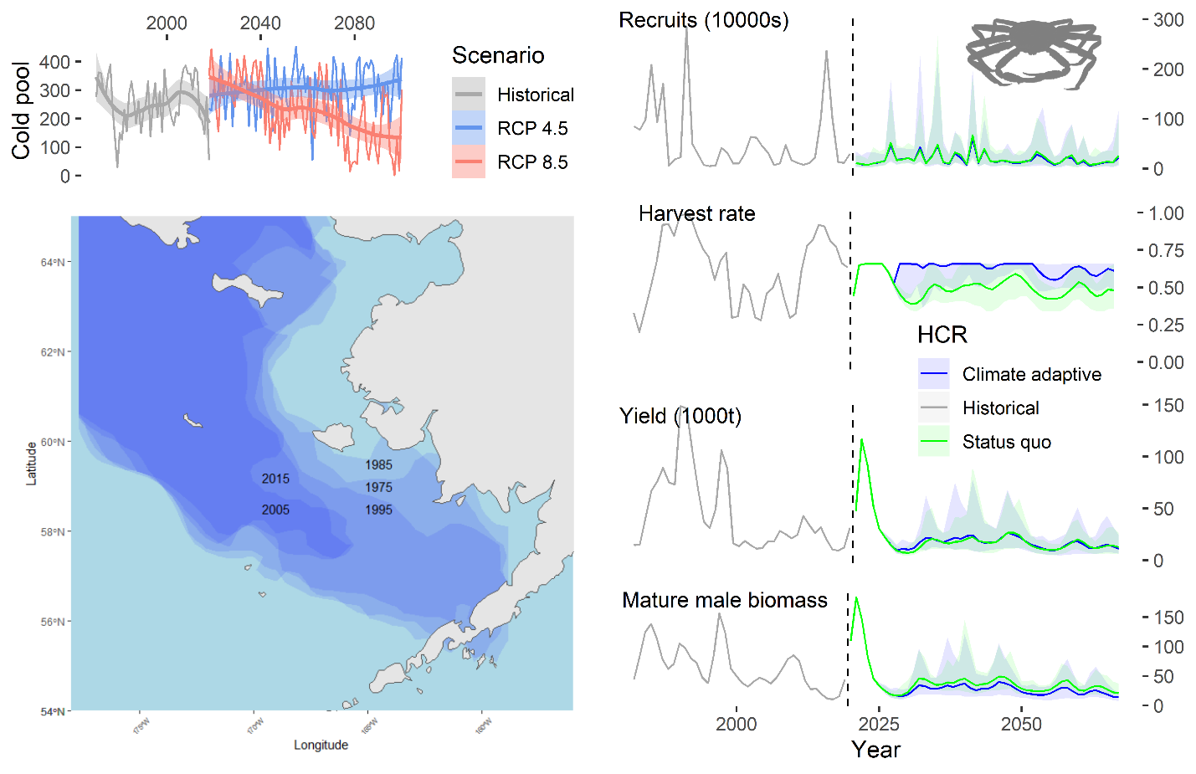

Figure 2. Climate-adaptive vs. status quo projections for snow crab in the eastern Bering Sea. Snow crab recruitment (top right) is projected to decrease as the cold pool shrinks in the Bering Sea. The historical cold pool, which is highly correlated with sea ice extent, is at left bottom. Projected cold pool at left top in terms of number of survey stations with bottom temperature below 2 C. Population projections are performed under RCP 8.5. See Figure S5 for magnified recruits and yields for the projection period.

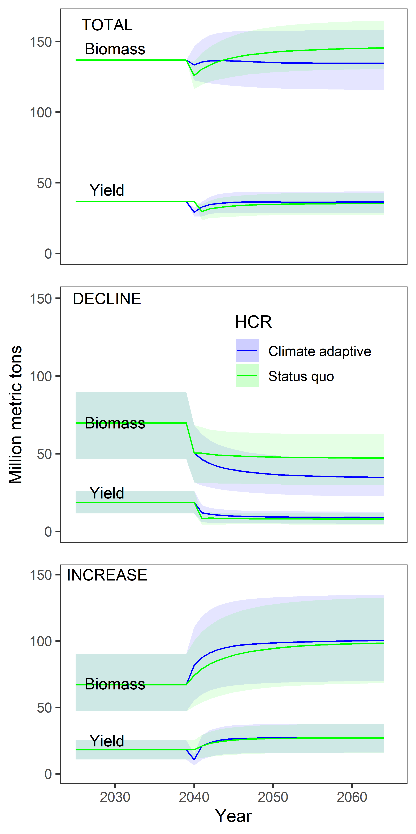

Figure 3. Projected aggregate biomasses and yields in millions of metric tons for 539 populations in the RAM Legacy Stock Assessment Database under climate-adaptive and *status quo* management targets. For each Monte Carlo simulation, populations are randomly assigned to either ‘increasing’ or ‘decreasing’ groups with a 50% probability. Totals are at the top; populations that experienced a decrease in productivity in the middle, and populations undergoing an increase in productivity are at the bottom. Solid lines represent the median value over the Monte Carlo simulations and shaded areas represent the 95% simulation interval.

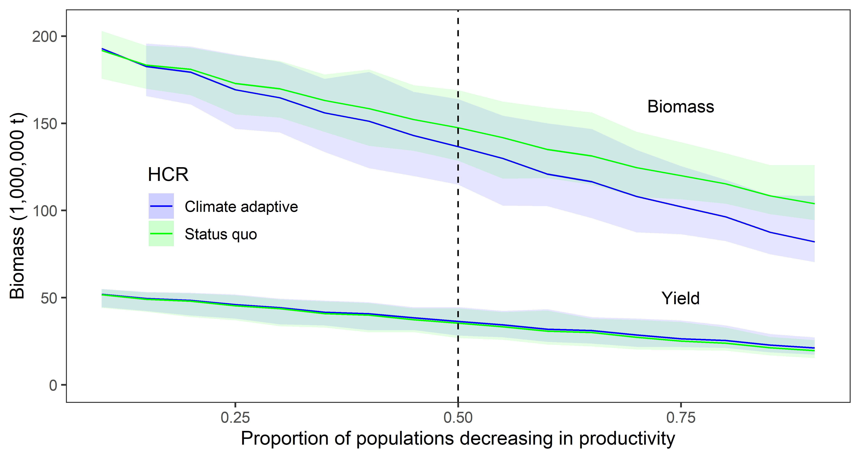

Figure 4. Aggregate equilibrium yield and biomass from RAM database populations for harvest control rules in which the management targets change or are maintained at *status quo* for a range of proportions of populations undergoing increases in carrying capacity vs. decreases. Vertical dashed line corresponds to scenario in figure 3.

**SUPPLEMENTARY MATERIALS**

**Methods**

***Simulated harvested population dynamics***

We first demonstrate problems associated with managing population undergoing changes in productivity with a biomass dynamics model. We simulated a population with a harvest history in which ‘effort dynamics’ determined the harvest rate (37). This simple model can be used to simulate the change in biomass, *B*, of a harvested natural living resource. Population dynamics are a function of an intrinsic rate of growth, *r*, the carrying capacity of the resource, *K*, and removals, *C*. The carrying capacity was specified to change half-way through the 100-year modeled time series from 1000 to 500, to mimic a change in productivity.

|  |  |
| --- | --- |
|  |  |

Where:

|  |  |
| --- | --- |
|  | Biomass at time *t* |
| *r* | Intrinsic rate of population growth (set to 0.25) |
| *K* | Carrying capacity (initially set to 1000) |
|  | Harvest from the resource at time *t.* |

The catch for years 1-3 is determined using an effort dynamics model

|  |  |
| --- | --- |
|  |  |

Where:

|  |  |
| --- | --- |
|  | Indicates what fraction of BMSY equilibrium occurs (set to 0.9) |
|  | Unexploited biomass |
|  | Adjusts the fraction of last year’s harvest applied based on the relationship of current biomass to the biomass at equilibrium (set to 0.2) |

The effort dynamics model is useful because it captures the oft-seen dynamics of the harvest of a resource overshooting appropriate levels, then being modified to reach management targets (10). It was used here to determine catches until year 50, when carrying capacity, and hence maximum production, changed, after which two different harvest control rules were compared.

A harvest control rule (HCR) using ‘climate-adaptive’ management targets was compared to a *status quo* HCR. Each HCR requires targets for harvest rates and biomass and a parameter that determines the slope of the descending leg of the HCR. The equilibrium biomass at which maximum sustainable yield (*BMSY*) occurs was half the carrying capacity in the simulation; the difference between the HCRs was the carrying capacity used to calculate the target biomass. The HCRs are ‘sloped’, which means that, as biomass declines below a target, the realized harvest rate was decreased from the target harvest rate. At biomass below 0.2BMSY, all fishing ceases.

|  |  |
| --- | --- |
|  |  |

Where:

|  |  |
| --- | --- |
|  | Harvest rate at time *t* |
|  | Target harvest rate |
|  | Biomass at time *t* |
|  | Target biomass |
|  | Determines the slope of the descending limb of the sloped control rule (set to 0.2) |

***Snow crab in the eastern Bering Sea***

Snow crab in the eastern Bering Sea have been harvested since the mid 1970s. The fishery is male-only and this is relatively easily enforced given strong sexual dimorphism. The snow crab fishery in the Bering Sea protects a large part of the mature male population through size restrictions. Although such restrictions are not always applied to harvested populations, in this case they allow for very high target fishing mortality rates on the fraction of the population that is exploitable. Maximum age for snow crab is likely no more than 20 years, but natural mortality is not precisely known. Snow crab molt annually, until a final molt to maturity, after which they do not grow. The reproductive dynamics appear to be strongly influenced by environmental conditions, particularly sea ice and the Arctic Oscillation (12). The population dynamics model used here to project the snow crab population in the eastern Bering Sea under climate change and different harvest control rules is a simplification of the model on which the current assessment is based and captures the above-mentioned characteristics of the fishery (38; see GitHub repository for code). The basic dynamics can be represented by:

where *Nt,l,m*is the numbers at the start of time-step *t* (there are three time steps in a year, summer survey, winter fishery, mating season) of length-class *l* and maturity state *m* (*m*=1 immature; 2=mature), *T*l is the probability of molting to maturity, Xl,l’ is a size-transition matrix that determines the how much a crab in length-class *l* grows when it molts, St,l,m is the survival during time-step *t* for animals in length-class *l* of maturity state *m*, *Rt* is the number of recruiting crab at the end of time-step *t*, and *P*l is the proportion of recruiting crab distributed to length bin *l*. The start of the model year is July 1. Parameters associated with these processes are estimated within the stock assessment and specified in the projection model used here (see github repo; figure S1). The size-transition matrix, the probability of terminal molt, the number of recruiting crab, and the proportion of recruiting crab are all directly input into the projection model. Other processes are derived from inputs as described below.

Survival is a function of natural mortality, *M*, during time-step *t* by maturity state *m,* fully selected fishing mortality (*Ft*), and fishery selectivity at length, *Vl*. Natural mortality and fishing mortality are inputs in the projection model.

Fishery selectivity is a logistic function of size with a maximum of 1 and probability of 50% capture (*V50*) of approximately 95 mm carapace width.

Growth per molt is specified by a linear relationship between expected growth increment and length. The variability around expected growth is specified by a discretized normal distribution, *Yl,l’*. These two pieces are combined to produce the entries of the size-transition matrix *Xl,l’*, used to determine the procession of crab from size *l* to size *l’* in the population dynamics model over time. Immature crab are assumed to molt every year.

Yields during time-step *t* (here fishing occurs six months after recruitment and the fishery is a pulse fishery) are a function of fishing mortality, weight-at-length, and numbers-at-length.

Mature male biomass during time-step *t* is calculated as the sum of the product of weight-at-length and the numbers by length-class of mature individuals in a given time step. The mature male biomass that determines recruitment is calculated in the third time step of each year, immediately after the fishery.

Only males are harvested in this fishery, consequently, only males are modeled and mature male biomass is used as a proxy for reproductive potential (both in this analysis and in management; 38).

*Estimates of recruitment, spawning biomass, historical environmental data*

Szuwalski et al. (12) developed a model to project snow crab recruitment under climate change using historical estimates of recruitment and mature female biomass, historical local and large-scale indices of environmental variation, and projected indices of local and large-scale indices of environmental variation. Here, that model is updated to use additional data and to incorporate mature male biomass (because only male biomass is modeled above). Estimates of recruitment and mature male biomass were taken from the most recent stock assessment for snow crab, which included both sexes (38). Estimates of recruitment were lagged 5 years to the year of fertilization (12).

The natural logarithm of the ratio of estimated recruits, *R*, to mature male biomass, *S*, was modeled as a linear function of female spawning biomass, *S*, and other environmental variables, *I*, in the form of a linearized Ricker curve (equation 3). A Ricker curve was chosen to accommodate the estimated large recruitments at intermediate values of mature male biomass observed in snow crab (39).

The Arctic Oscillation and ice extent were significant predictors of snow crab recruitment in Szuwalski et al., (12) and they remained so after using mature male biomass in place of mature female biomass. Data for these environmental variables were collated from the National Oceanic and Atmospheric Administration’s “Bering Climate” data portal (40).

*Projections of productivity*

The Alaska Climate Change Integrated Modeling project (﻿ACLIM; 29) recently produced high resolution downscaled projections of oceanographic conditions in the Bering Sea using the Regional Ocean Modeling System and the global climate model GFDL-ESM2M. CMIP5 representative concentration pathways (RCP) 8.5 (high baseline carbon emissions) was used to drive the boundary and atmospheric conditions of the regional model (41, 42). For each projection, the National Marine Fisheries Service Alaska Fisheries Science Center annual summer bottom-trawl survey was replicated in time and space (using historical mean survey date at each latitude and longitude of each gridded survey station) to derive estimates of bottom temperatures.

Projections of the Arctic Oscillation (AO, also known as the Northern Annular Mode; NAM) were obtained from the global climate model GFDL-ESM2M to remain consistent with the model above (43). In particular, the 2020-2100 period of the RCP 8.5 simulations were applied in this study to obtain the AO indices to establish a scenario of concerning warming for the Bering Sea. The first EOFs of SST and sea level pressure, obtained over the Northern Pacific Ocean and Northern Hemisphere from reanalysis datasets (HadISSTv1.1 [44] and NOAA-CIRES 20CR [45], respectively) for a historical period (1900-2005), were projected to future projection simulations to obtain the associated principal component (PC) time series, which were then used as the future projections of the AO indices in this study. The detailed description for the methodology can be found in Lee et al. (46).

*Management targets and projections for snow crab*

Proxies for biomass and fishing mortality management targets were calculated for snow crab using spawner-per-recruit methods (*sensu* 47). B35% is the biomass at which spawning biomass per recruit is 35% of unfished levels and has been shown to provide close to maximum sustainable yield for a range of steepness (i.e. the fraction of unfished recruitment achieved at 20% of unfished spawning biomass; 47) values. Consequently, it is an often-used target when stock-recruitment relationships are poorly defined (as is the case for snow crab and many marine stocks globally). To calculate management targets, the snow crab population dynamics model was projected forward 100 years using the specified parameters under no harvest to determine 'unfished' mature male biomass-per-recruit. Projections were repeated in which a fishing mortality that reduced the mature male biomass-per-recruit to 35% of the unfished level was calculated (i.e. F35%). B35% was calculated by multiplying the mature male biomass-per-recruit by the average recruitment over a defined period of time. The *status quo* harvest control rule used the entire time period of recruitment since 1982 (updated each time the projection moved forward a year). The adaptive harvest control rule used the average recruitment from the year 2025 once the projection moved beyond the year 2030; before that the same recruitment calculated for the *status quo* rule was used.

*Changes in other population processes*

In addition to changes in recruitment, changes in processes such as natural mortality or growth will also affect estimated population status and dynamics, and will result in changes in management targets incorporated into harvest control rules. We demonstrated the effects of a change in natural mortality and growth on management targets here by projecting the snow crab model described above forward to the year 2060 with small changes. First, rather than changing projected recruitment functions, we changed natural mortality or growth in the year 2030 (figure S2). The selectivity and probability of terminal molt were also adjusted to reflect a fishery in which a larger fraction of the mature biomass is vulnerable to capture to allow for better differentiation between the scenarios. Spawning biomass-per-recruit proxies for target biomasses and fishing mortalities were calculated for each value of natural mortality or growth (i.e. the pre- and post-change natural mortalities; 0.3 and 0.4, respectively) and the resulting harvest control rules (figure S3) were used to project the population forward after the shift in productivity (figure S4).

Both management targets changed when natural mortality or growth changed, which is an important difference between the scenario in which recruitment changed and only the target biomass changed. When natural mortality increases or growth decreases, the population is less ‘productive’. For a given number of new recruits to the population, the mature biomass produced decreases when natural mortality increases or growth decreases. The overall ‘scale’ of the population decreases, and the crab die at a smaller size on average. Consequently, the optimal age/size at harvest decreases to balance the tradeoff between growth and natural mortality. This translates to higher target harvest rates and lower target biomasses. This implies a ‘double-threat’ because, as the population is stressed by increasing natural mortality or decreased growth, adapting the harvest control rule to changing environmental conditions would result in both lower biomass targets and higher harvest rates.

***Global fisheries***

The RAM Legacy Stock Assessment Database (RAMLDB) is the most extensive and in depth database available describing the dynamics of harvested marine populations (23). The RAMLDB is a collection of the output of over 590 stock assessments, representing populations that account for 34-49% of global catch (depending on the year of comparison--some of these assessments are only up-to-date through the end of the 2000s). Stock assessments generally incorporate all available data and model the idiosyncrasies of life history and harvest patterns specific to each fishery (the eastern Bering Sea snow crab fishery described above is one such population and is included in the RAMLDB). Consequently, the output of these models represents the best available scientific information available for each population.

It is not possible to recreate every stock assessment that produced the output in the RAMLDB in a single, inclusive model to test harvest control rules in a projection. However, it is possible to fit simpler models to the output contained in RAMLDB and use those for projections. Simpler models lose much of the details of a fishery, but approximately preserve the scale and biomass dynamics. We fit Pella-Tomlinson surplus production models (48) to total biomass (*B*) and catch (*C*) reported in the RAMDLB:

Where

|  |  |
| --- | --- |
| *uMSY* | Harvest rate at which maximum sustainable yield occurs |
| *BMSY* | Biomass at which maximum sustainable yield occurs |
|  | Determines the shape of the production function |

Fits to the data by production models were subject to checks related to time series length, convergence of the optimization algorithm, and reasonable estimates of target exploitation rates and biomasses (see 49 for a complete description of the criteria). This analysis includes 529 populations that met these criteria (Figure S6). The overarching goal of the fitting was to produce populations to project that were of the approximate scale of those represented in the RAMLDB, and the modeled populations achieve this objective. Models were projected for 50 years (starting in 2015), during which all populations experienced a shift in carrying capacity after 25 years. The performance of a climate-adaptive rule and a *status quo* rule (similar to the rules described above for the simulated population) were compared in terms of projected yield and biomass in the water.

Biomass dynamic models do not provide a good basis for managing natural resources. They miss important details in population and harvest dynamics (e.g. gear selectivity is important and not all individuals are equal in reproduction) and estimated management targets compared poorly with those from more complex assessment models (50, 51). Within the RAMLDB, the correlation between BMSY from the assessment and BMSY estimated from production models was 0.55; the correlation between UMSY from the assessment and UMSY estimated from production models was 0.58. Production models are even worse tools to try to identify drivers of changes in productivity because inherent changes in productivity occur as a result of transient effects of changing age structure unrelated to external drivers (52, 53). Despite their limitations, production models are useful in our analysis for comparisons of harvest control rules, which does not require a model to fully capture the dynamics of a population. Our use of production models here is not an endorsement of their use for management, only a useful simplification with which to test harvest control rules that captures the approximate scale of managed fisheries at the global scale.

***Projected impacts of climate change***

The impact at the global scale of climate change on fisheries is uncertain, in spite of many attempts to quantify the impact of climate change on future fisheries in the scientific literature. It is difficult to understand how multiple interacting stressors and the potential for adaptation will influence the future productivity of populations. So, rather than attempt to predict the impact of climate change on resources, our focus is understanding the impact of management on the trajectory of changing resources. To accomplish this, we performed 100 Monte Carlo simulations in which the carrying capacities of populations were multiplied by a randomly distributed normal variable with a mean of either 0.5 or 1.5 and a standard deviation of 0.1. Populations were assigned to the ‘increasing productivity’ group with a probability of 50% for the first analysis. Assignment of a stock to an increasing or decreasing productivity group was also random across the simulations, so that over the simulations, a given stock increased half of the time and decreased half of the time on average. This guards against the potential of a single large stock influencing the results.

Changing the productivity in this manner ensures that the future aggregate productivity of fisheries remains roughly the same and provides a stable basis of initial comparison of the harvest control rules. However, it is possible (or even likely) that the distributions of increases and decreases in productivity will not be equal. We therefore examined a range of probabilities (5 to 95%) for being assigned to the ‘increasing productivity’ group.

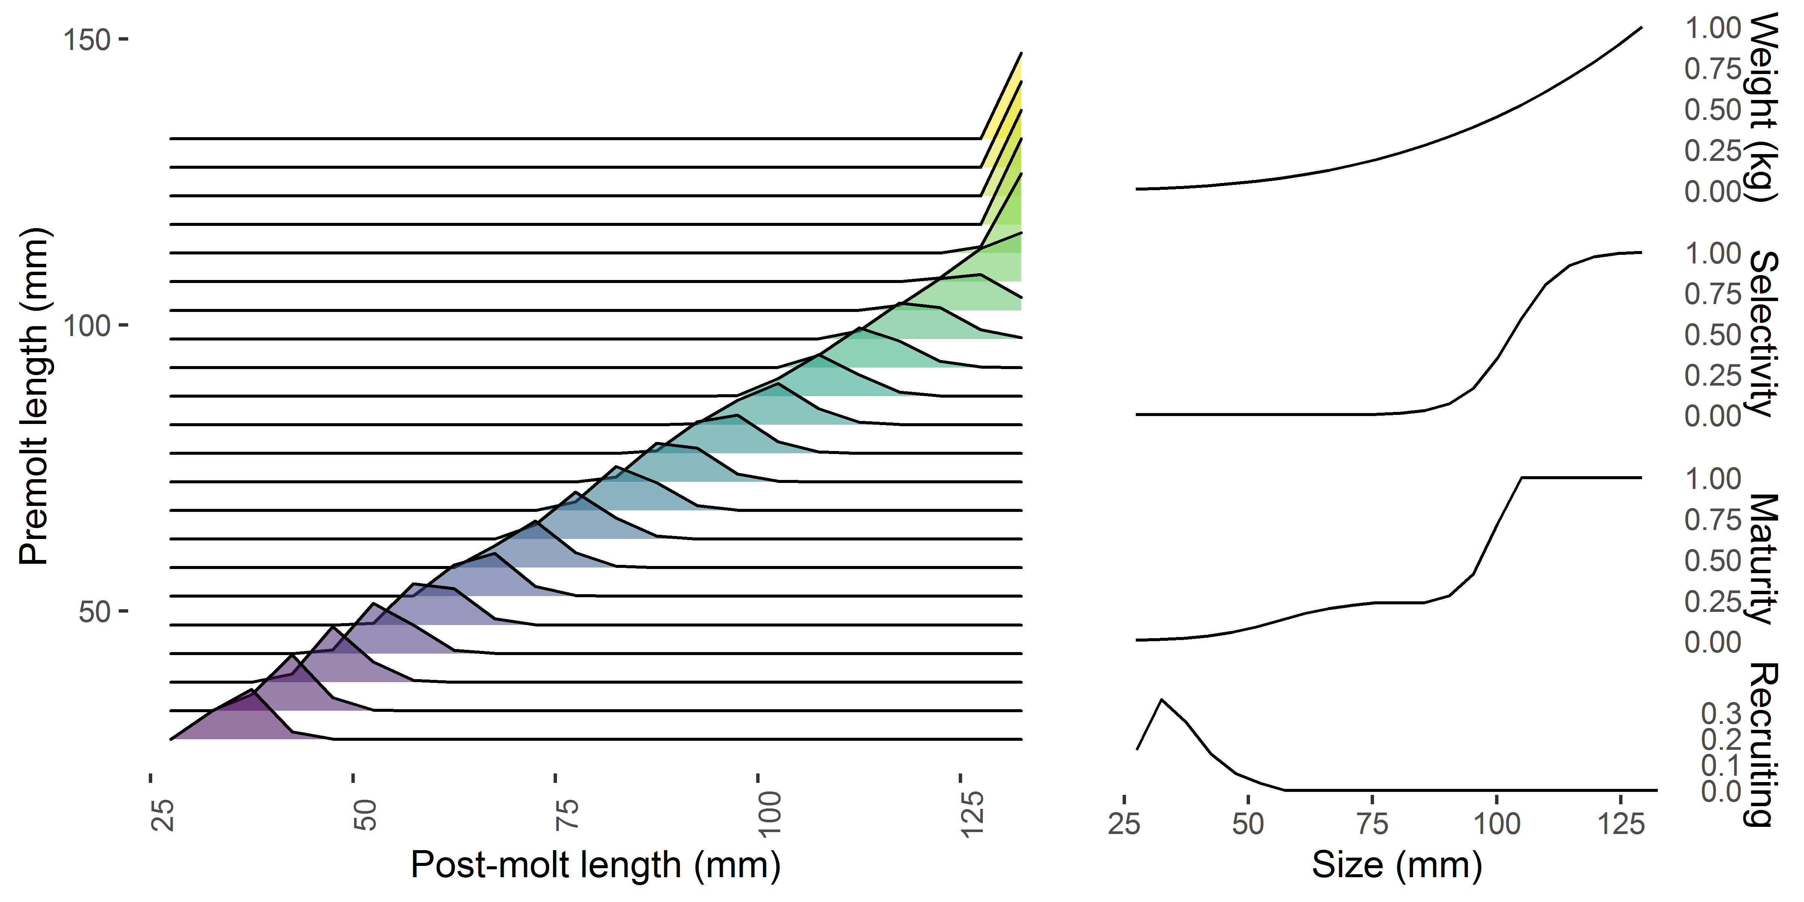

Figure S1. Population specifications for the snow crab model when projected recruitment responds to a changing climate. The size-transition matrix is at the left; weight-at-size, fishery selectivity-at-size, probability of maturing at size and the size at recruitment (top to bottom, respectively) are at the right.

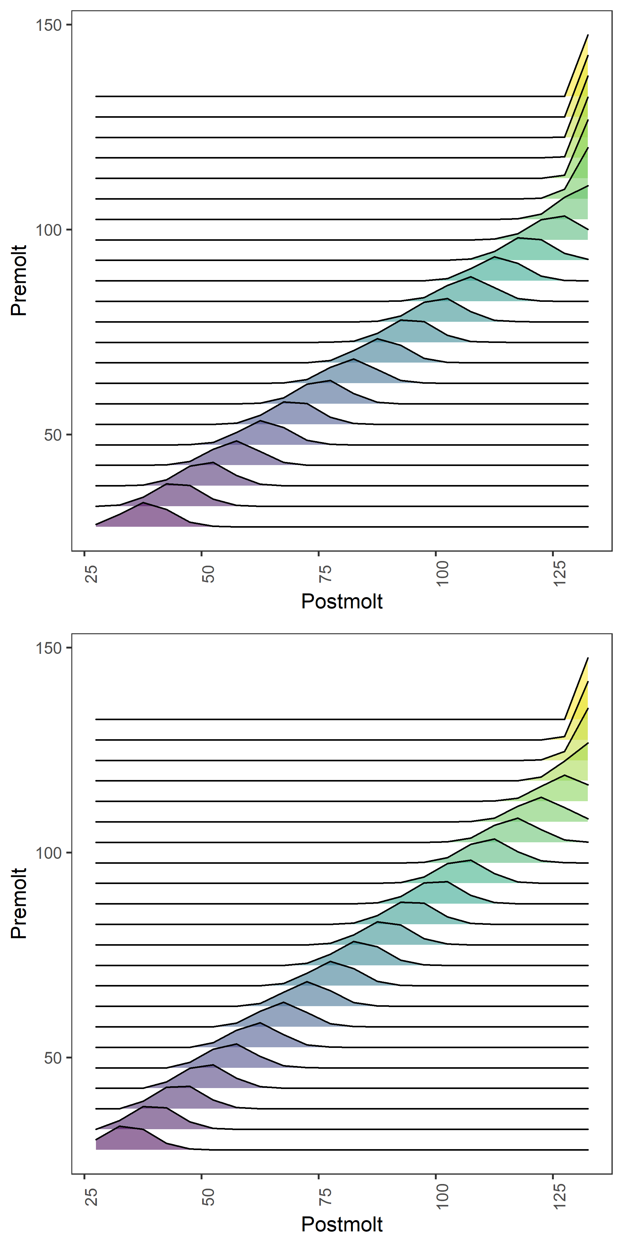

Figure S2. Change in the size-transition matrix for the growth-based snow crab example. The x-axis is the post-molt carapace size; the y-axis is the pre-molt carapace size. The distributions represent the distribution of crab molting from one size class (y-axis) to others (x-axis). The top panel represents ‘more productive’ growth—the growth per molt at a given size is larger than in the bottom panel.

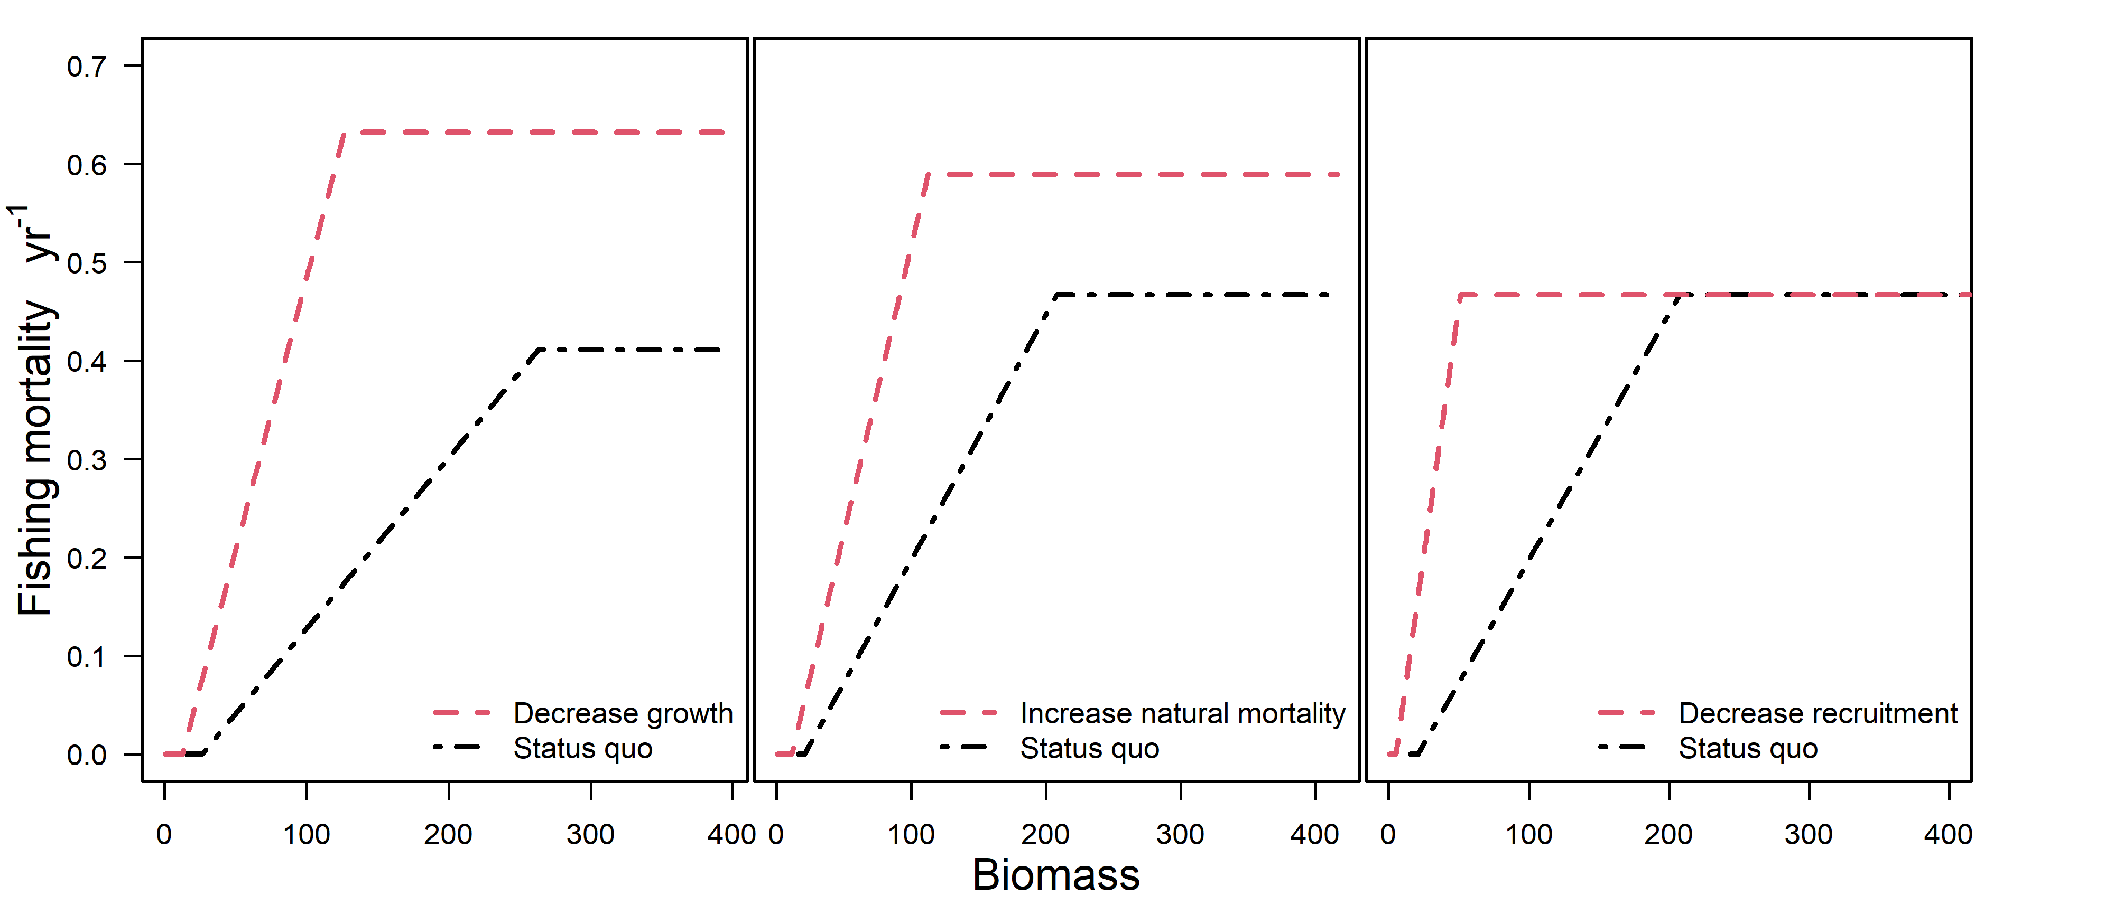

Figure S3. Sloped harvest control rules for a population similar to snow crab in the Bering Sea under shifts in natural mortality, growth, and recruitment.

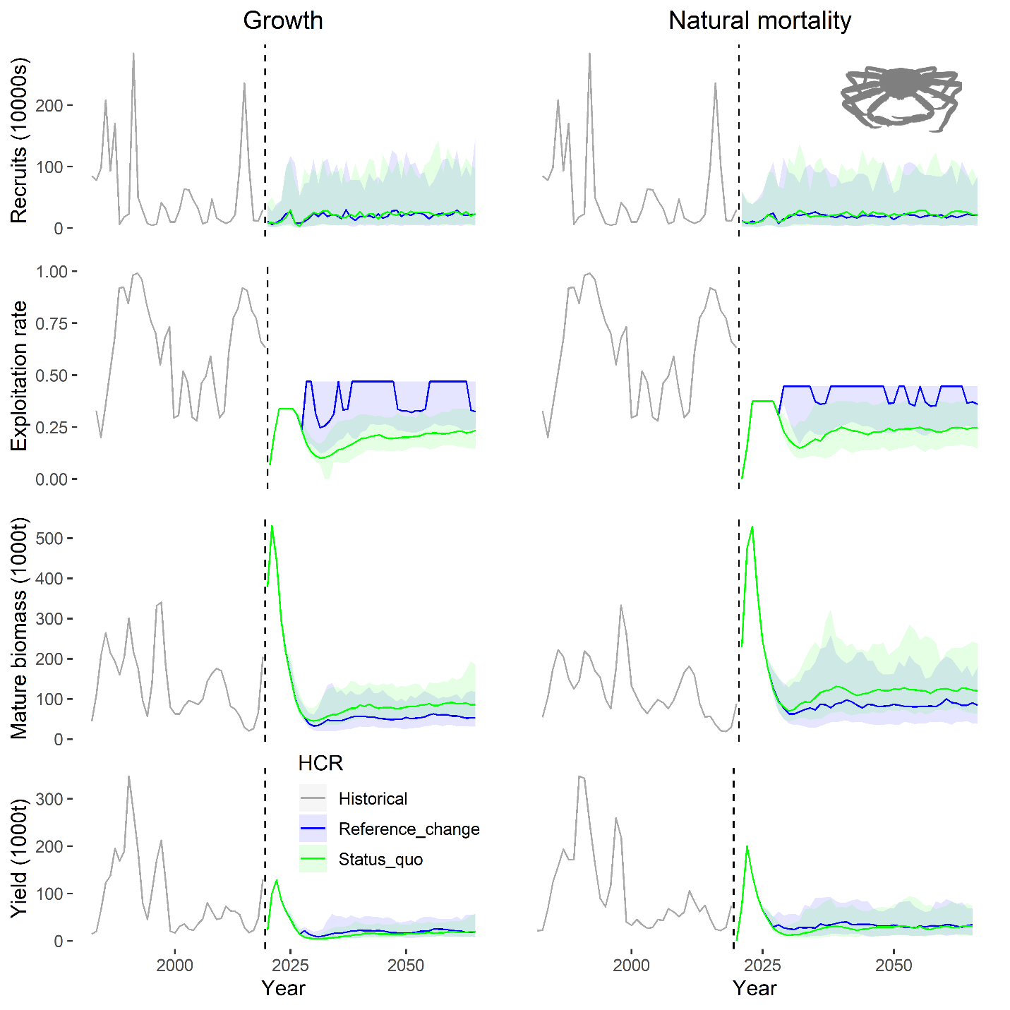

Figure S4. Management projections for snow crab in the eastern Bering Sea under changes in natural mortality and growth. Shading represents the 95% quantile from the Monte Carlo simulation performed over recruitment variability.

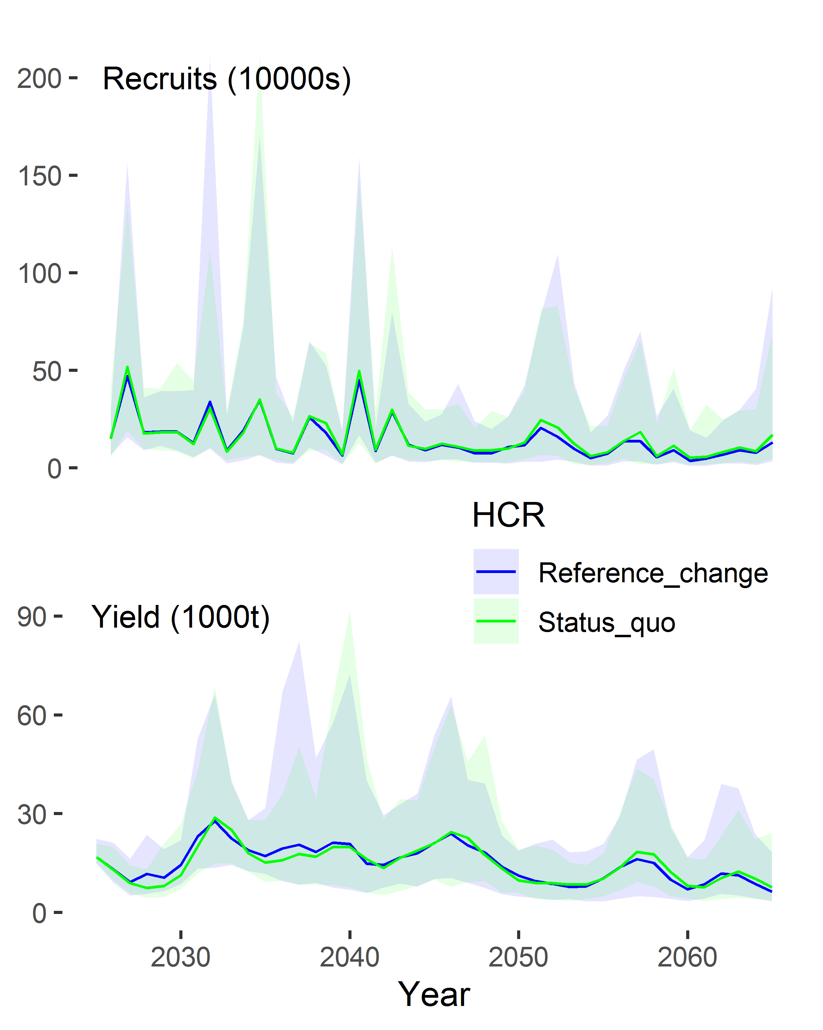

Figure S5. Magnification of recruitment and yield from the projection period from figure 2.

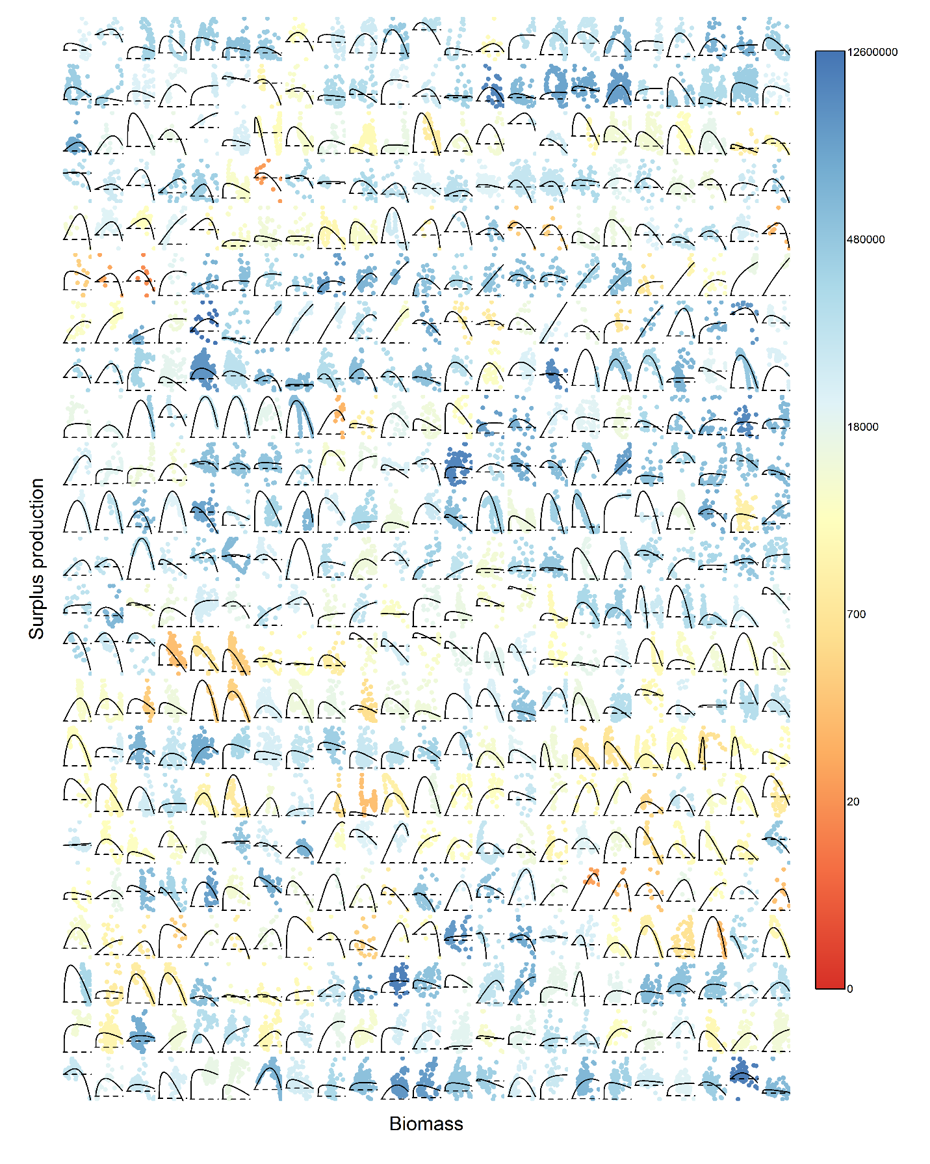

Figure S6. Model fits to surplus production for populations from RAMLDB used in the analysis (n=539). Color of data points for each population represents the magnitude of the estimated BMSY for the population in tonnes (either from the assessment or from the surplus production model fit to assessment outputs). Horizontal dashed lines show surplus production values of 0.